Adam Gincel

BT321

Problem Set 1

*I pledge my honor that I have abided by the Stevens Honor System.*

1. Question 1
   1. 1.1
      1. Monthly payment: N = 15 * 12 = 180, PV = 500000, i/y = 4%/12 = 0.3333%, fv = 0, **PMT = Xa = 3698.44**
      2. 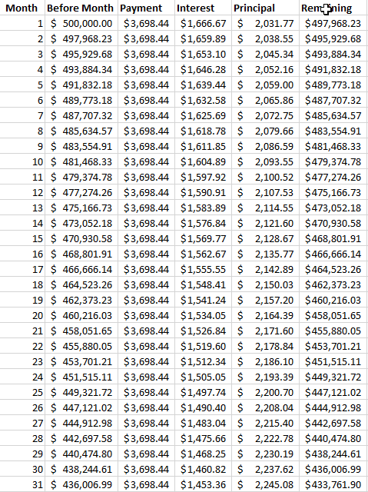
      3. 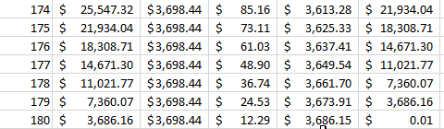
      4. The first column shows the amount money remaining on the loan before the payment is processed. As this is a fixed rate loan, the payment remains the same each month. This is Xa, calculated in 1a using a Financial Calculator. Interest is then calculated as 0.3333% of the current value of the loan (column A). Principal is the total payment minus interest. Principal is then subtracted from the before value, to get us our new remaining value for the following month. This is repeated until the loan reaches 0 (in this case 1 cent), 180 months later.
   2. 1.2
      1. After 36 months of paying at Xa / 2, or $1849.22, the PV of the loan is $493029.84. Using a Financial Calculator with N = 180 – 36 = 144, I/Y = 0.3333%, PV = 493029.84, FV = 0, **PMT = Xb = $4319.62.**
      2. 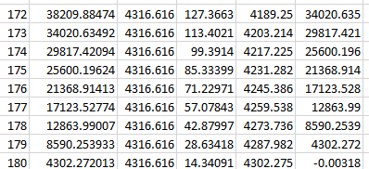
      3. As we can see, this converges to $0 at 180 months, as expected.
   3. 1.3
      1. In contract A we see tax savings of $48,660.19. In contract B we see tax savings of $55,480. This makes Contract B more preferable, as it has a higher tax shield value of debt.
      2. Applying this to Question 4’s early payment gives us Tax Savings of $36,807.76. As this payment plan ends sooner, it makes sense that this yields less interest, and thus, less tax savings.
   4. 1.4 Extra Credit
      1. At the end of Month 60, the remaining amount on the Loan is $426,352.92. Using a Financial Calculator, with N = 4 * 12 = 48, i/y = 0.3333%, PV = 426352.9249, FV = 0, **PMT = Xc = $9626.6459**
      2. 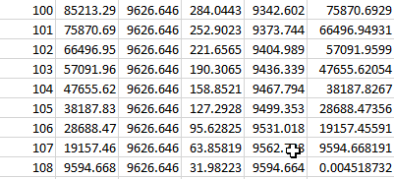
      3. As we can see, from setting the payment to Xc from months 61 to 108 yields a FV of 0, as expected.
2. Question 2
   1. Using PV = $120,000, I/Y = 3.45%/12 = 0.2875%, N = 10y * 12m = 120, FV = 0, **PMT =** $1183.8218
      1. 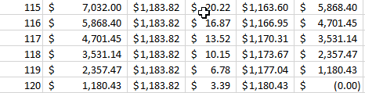
      2. As we can see, if rates were unchanging, using this payment value we would reach FV $0 in 120 months, as expected.
   2. Paying the exact rate of $1183.82 each month yields $109,773.44 remaining at the end of 2017. Using this value into 2018 with N = 108, PMT = $1250, PV = 109773.44, FV = 0, **I/Y = 0.3941**
      1. Times 12, this gives us 4.7292%, which, -1% to account for premium, gives us 3.7292%. This means that the Treasury rate would have to spike to increase from 2.45% to 3.7292%, a change of 1.2792%, to cause Aaron to start defaulting on his loan.
   3. If Aaron had been paying $1250 each month through 2017, at the end of the year there would be $108,966.62 remaining on his account. Substituting that value into the Financial Calculator solution from before yields **I/Y = 0.4087**
      1. Multiplied by 12, this gives us 4.9048%. Subtract 1% to account for the premium, which gives us 3.9048%. This means the Treasury rate would have to spike 1.4548% to cause Aaron to start defaulting on his loan.
3. Question 3
   1. To determine the current interest rate I used N = 360, PMT = -2000, FV = 0, and PV = 400,000, as that is the 80% debt of the $500,000 house. This yielded 0.3656% per month, or 4.3871% per year.
   2. Using these numbers, we can experiment with the interest rate and see that, should the interest rate fall to 0.2161% per month, or 2.5932% per year, that the PV of the loan will exceed the total value of the house.
   3. As such, once interest rates fall that low, it would make sense to strategically default on this loan, as the loan is more of a burden than the house in that given market.
4. Question 4
   1. Using a Financial Calculator with N=96, i/y=0.458333, PV=65000, FV=0, I determined **PMT=$838.4558 a month**.
      1. Using this we can replace i/y with 4%/12 = 0.3333% and determine the new PV of that refinanced loan, which would be **PV = $68786.3548**
         1. This is a $3786.3548 increase in value.
   2. To be offered $5000 to take this refinance is a bad deal, as you only gain $3786.3548. In short, that would make you lose $1213.6452.
      1. The absolute maximum fee that should be accepted for this refinance is the total amount gained, $3786.3548, but even then it wouldn’t make sense as it would be a net zero to the loanholder. A value sufficiently below that maximum would be best.